Snow Machine Assembly
- Lay out the flat snow machine box on a large flat shop table.
- Before hot gluing each area or panel, fold over the panels along the score marks/lines made by the box die. This will make gluing easier and cleaner looking.
- Notice there are two parallel score lines close together that represent the top edge of the snow machine. Both of these lines need to be broken/folded and pushed down with your hands in a way that the top edge is square and like the pic. .
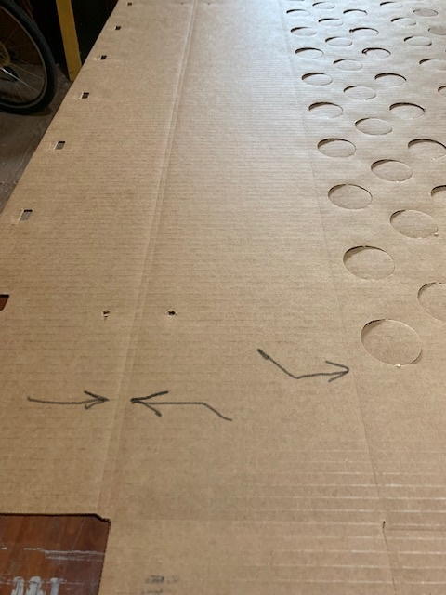

- Notice there are two parallel score lines close together that represent the top edge of the snow machine. Both of these lines need to be folded and pushed down with your hands in a way that the top edge of the machine is nice and square and not tapered with an edge by the time you glue it.
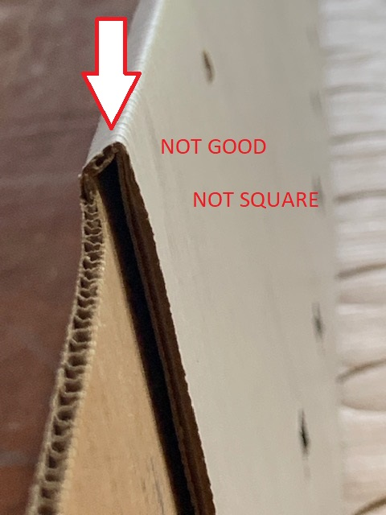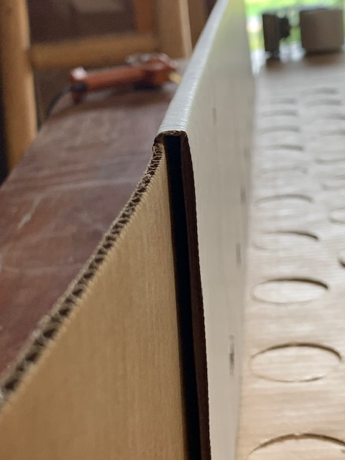

- Once the edges are broken, flatten out again and squeeze two long beads of hot glue on the long side that has the rectangular holes/slots. One bead should be in the middle and the other between the bottom edge and the rectangular slots. No need to over glue it. Hot glue works amazing with wood and card board so only a little will do.

- After running your two hot glue beads (which should take about 10 seconds) put the glue gun down quickly and fold over the panel, pressing down on the top edge and the falts areas (see video). Keep doing this for about 20 seconds or long enough for the glue to cool and bond. If you let go too soon the panel will pull apart. Typically, the thicker the bead of hot cool the longer it takes to cool. Turn the machine around and glue the next panel and repeat.

- Next you glue up the ends. Grab flaps or wings that remain on the long sides and pull them up together. Holding them together with one hand, glue the bottom end piece. One bead of glue on each edge and them some glue in middle.
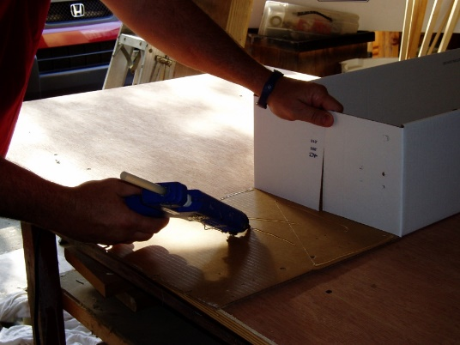 SEE VIDEO IN EMAIL
- Next, grab the machine and pull it up vertical and glue in place lining up the edges nice and square. Don’t worry about the pre-cut holes, they tend to line up themselves rather well.

- Next, glue the inside so as to receive the flap. Lift the flap over and press in place. Repeat.

- The box is now glued up. Everything is downhill from here. I use a 3/8” round metal file to prep and bore out the pre-cut holes. I use one end to ream and open the large hole for the electric cord.
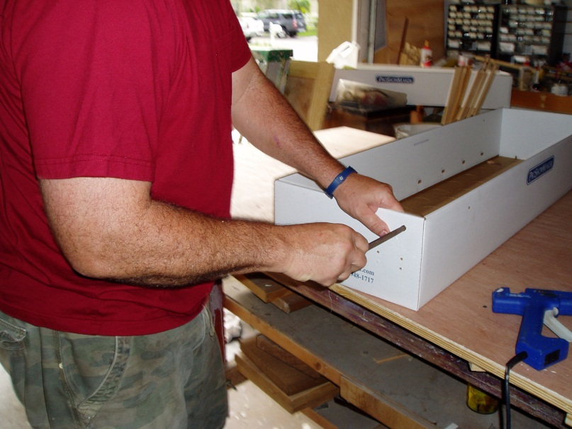

- The other pointed end to ream out the smaller holes for the motor bracket.
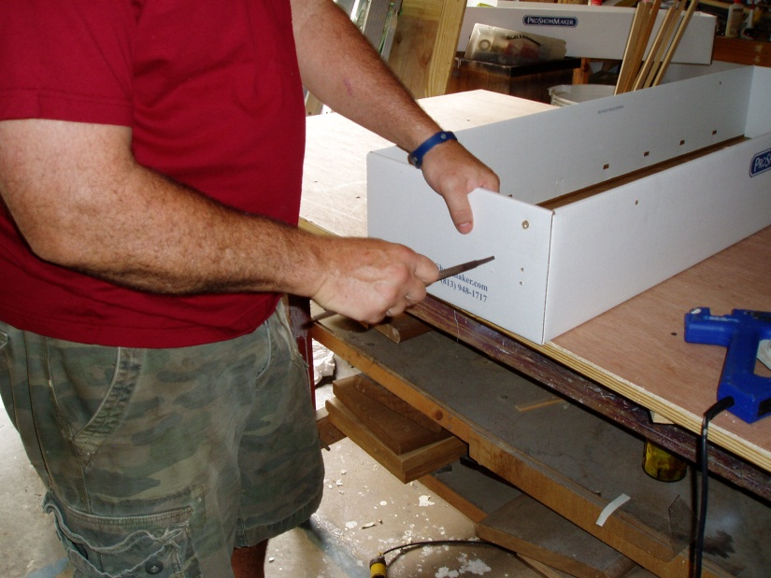
- Next, find the large plastic shoulder washer and press it part way into the reamed hole. Add a touch of glue and press it all the way in.
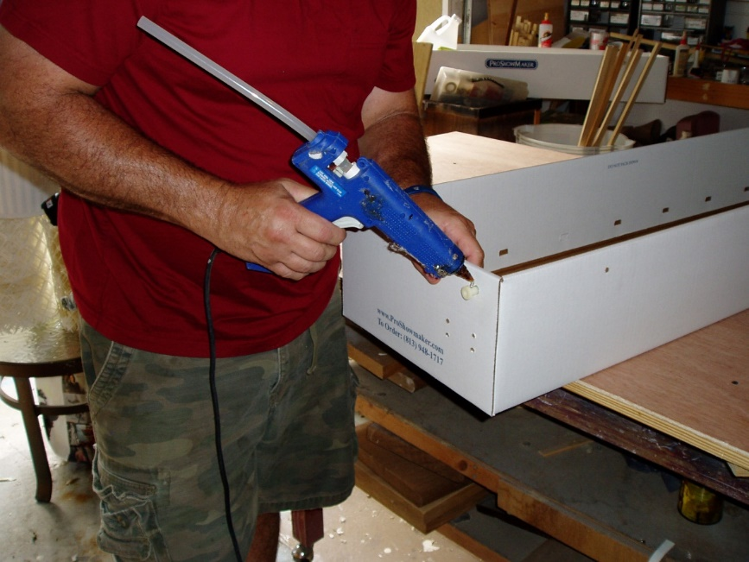
Erich, you may find better ways to do things. If you do great….and please share. Two minds are always better than one.
Here is the order we use to finish it out.
- Attach metal linkage to plastic grid. Don’t over tighten and it needs to move.
- Install motor to inside of machine box. Use 4 bolts and nuts. You need good fingers
- Attach electric cord to motor. Push cord through the shoulder washer and wire it up to the motor. We use orange wire nuts in U.S. but I’m sure you have another method.
- With motor mounted, attach short metal arm over the motor shaft and tighten with key wrench.
- Now put on the handles. Ream the 4 holes out a bit. Push in the plastic shoulder washers, wood screws, and hang the strap hook onto the screws.
- Grab two handles and install by drilling the screws into the center of the handle. Grab wood handle firmly with left hand and drill screw in with a cordless drill in right hand. The screw goes in pretty easy as you are screwing into the end grain of the wood. Snug the screw up tight but not too tight. You don’t want the strap hook to flop around.
- Finally, and this can be done earlier in assembly, drip glue onto the corners of machine. In the past I have spent money on custom plastic guards that we glued on. These took more time and added more $$ and glue burns to our hands. Finally, I just decided the visible glue to be enough for corner protection and be a sign that the machine was sturdy.
